10/10/2025

(20116870) Sophie Teodoro Neves

SETU

Measuring the boiling point of water at different altitudes



Table of contents

**Title**………………………………………………………………………………………………………………………………………….......**..2**

1. **Aim………………………………………………………………………………………………………………………………….2**
2. **Theory……………………………………………………………………………………………………………………………..2**
   1. **Introduction to Clausius-Clapeyron equation……………………………………………………………..2**
   2. **Relationship between boiling point and temperature………………………………………………..3**
3. **Apparatus………………………………………………………………………………………………………………………..3**
4. **Method……………………………………………………………………………………………………………………………4**
5. **Calculations………………………………………………………………………………………………………………….….4**
6. **Discussion/Conclusion…………………………………………………………………………………………………….4**

# **Title**

Measuring the boiling point of water at different altitudes

# **1.Aim**

To determine how altitude affects the boiling point of water and to compare the measured

values with theoretical expectations.

# **2. Theory**

2.1 INTRODUCTION TO CLAUSIUS–CLAPEYRON EQUATION

The **Clausius–Clapeyron equation** describes how the pressure and temperature of a

substance are related during a phase change — for example, when a liquid boils or a solid

melts.

It shows that as temperature increases, the vapour pressure of a liquid also increases. This is

because heating gives the molecules more energy to escape from the liquid surface.

In this experiment, the equation helps explain **why the boiling point of water decreases at**

**higher altitudes:**

* Air pressure is lower at high altitudes.
* According to the equation, lower pressure means boiling happens at a lower

temperature.

## **2.2** RELATIONSHIP BETWEEN BOILING POINT AND PRESSURE

The relationship between boiling point and pressure can be estimated using the Clausius–

Clapeyron equation:

$$ln\left(\frac{P^{1}}{P^{2}}\right)=\frac{{∆H}_{vap}}{R}\left(\frac{1}{T_{2}}-\frac{1}{T_{2}}\right)$$

where ${∆H}_{vap}$ is the enthalpy of vaporization, **R** is the gas constant, and **T** represents absolute

temperature.

# **3. APPARATUS**

* Thermometer
* 250 mL Beaker
* Hot plate
* Distilled water
* Barometer
* Stopwatch

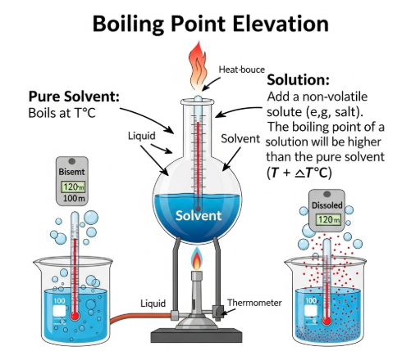

# **4. METHOD**

1. Fill a 250 mL beaker halfway with distilled water.

2. Measure and record the atmospheric pressure using a barometer.

3. Place the beaker on a hot plate and heat gradually.

4. Record the temperature at which vigorous boiling begins.

5. Repeat the experiment at three simulated altitudes by adjusting the air pressure in a sealed chamber.

6. Record all data and calculate the boiling point deviation from the theoretical 100 °C.

|  |  |  |  |  |  |  |  |  |  |  |  |  |  |  |  |  |  |  |  |  |
| --- | --- | --- | --- | --- | --- | --- | --- | --- | --- | --- | --- | --- | --- | --- | --- | --- | --- | --- | --- | --- |
| |  |  |  |  | | --- | --- | --- | --- | | Altitude(m) | Pressure(kPa) | Boiling point ($℃$) | Deviation () | | 0 | 101.3 | 100.0 | 0.0 | | 500 | 95.5 | 98.6 | -1.4 | | 1000 | 89.9 | 97.2 | -2.8 | | 1500 | 84.2 | 96.0 | -4.0 | |

# **5. CALCULATIONS**Percentage deviation from standard boiling point (100 °C):

Percentage deviation = $\frac{100-T_{measured}}{100} x 100$

At 1500 m, deviation = $\frac{4}{100 } x 100=4\%$

# **6.DISCUSSION/CONCLUSION**

The data clearly shows a decrease in boiling point with increasing altitude, consistent with the theoretical relationship between pressure and temperature.

Minor experimental deviations could result from thermometer calibration or inconsistent

pressure readings.

This experiment demonstrates the importance of considering environmental conditions in

temperature-sensitive scientific measurements.

**References**

https://www.google.com/url?sa=i&url=https%3A%2F%2Feasy-peasy.ai%2Fai-image-generator%2Fimages%2Funderstanding-boiling-point-elevation-educational-illustration&psig=AOvVaw2AFskAzbcTpWJA6lX5QMBv&ust=1760192430179000&source=images&cd=vfe&opi=89978449&ved=0CBgQjhxqFwoTCNDc4YXqmZADFQAAAAAdAAAAABAE